Snowball:

Before snowball there was a legacy service.

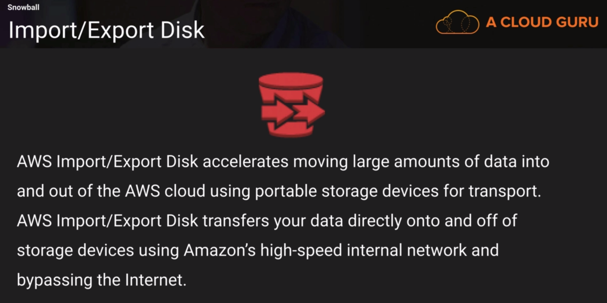

If you had a slow network and wanted to transfer lot of data to s3, you send disks to amazon who will import them to s3 bypassing the internet. But everybody started sending all kinds of devices.

So, amazon created snowball. It can import to and export data from s3.

There are 3 types:

* Snowball
* Snowball edge
* Snowmobile

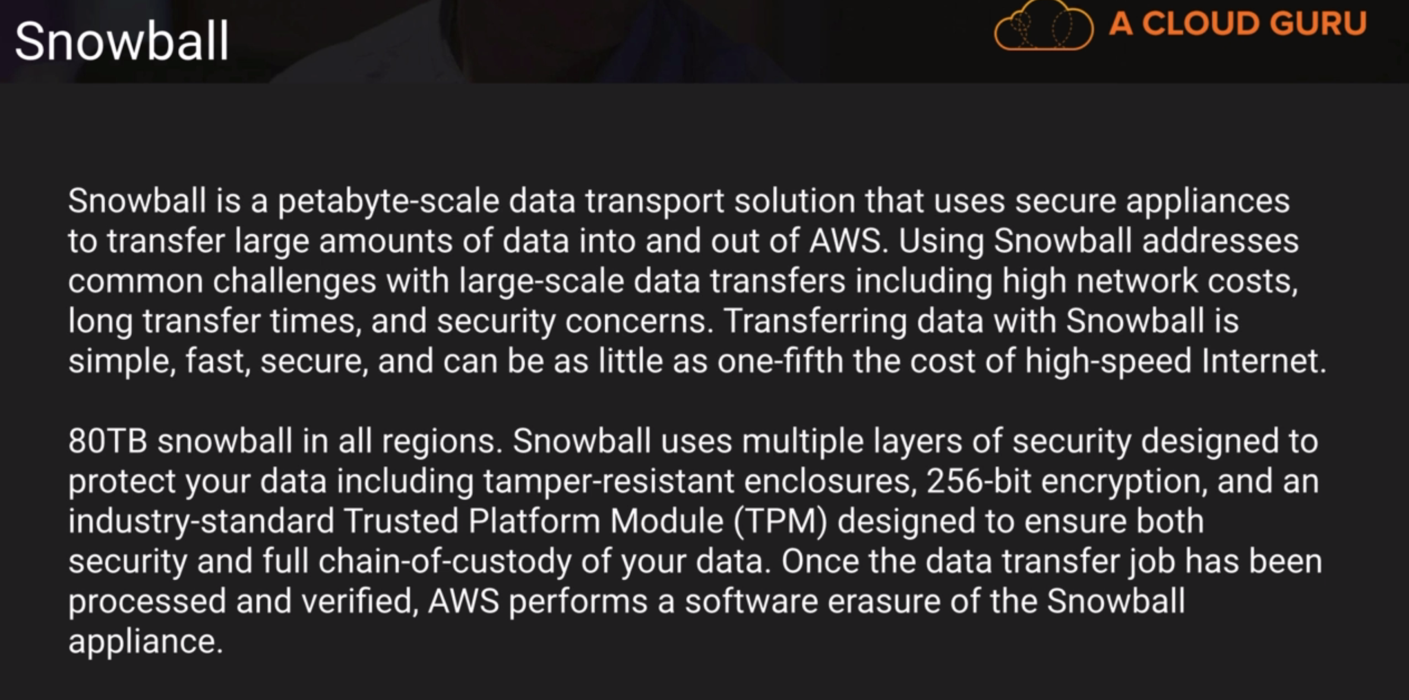

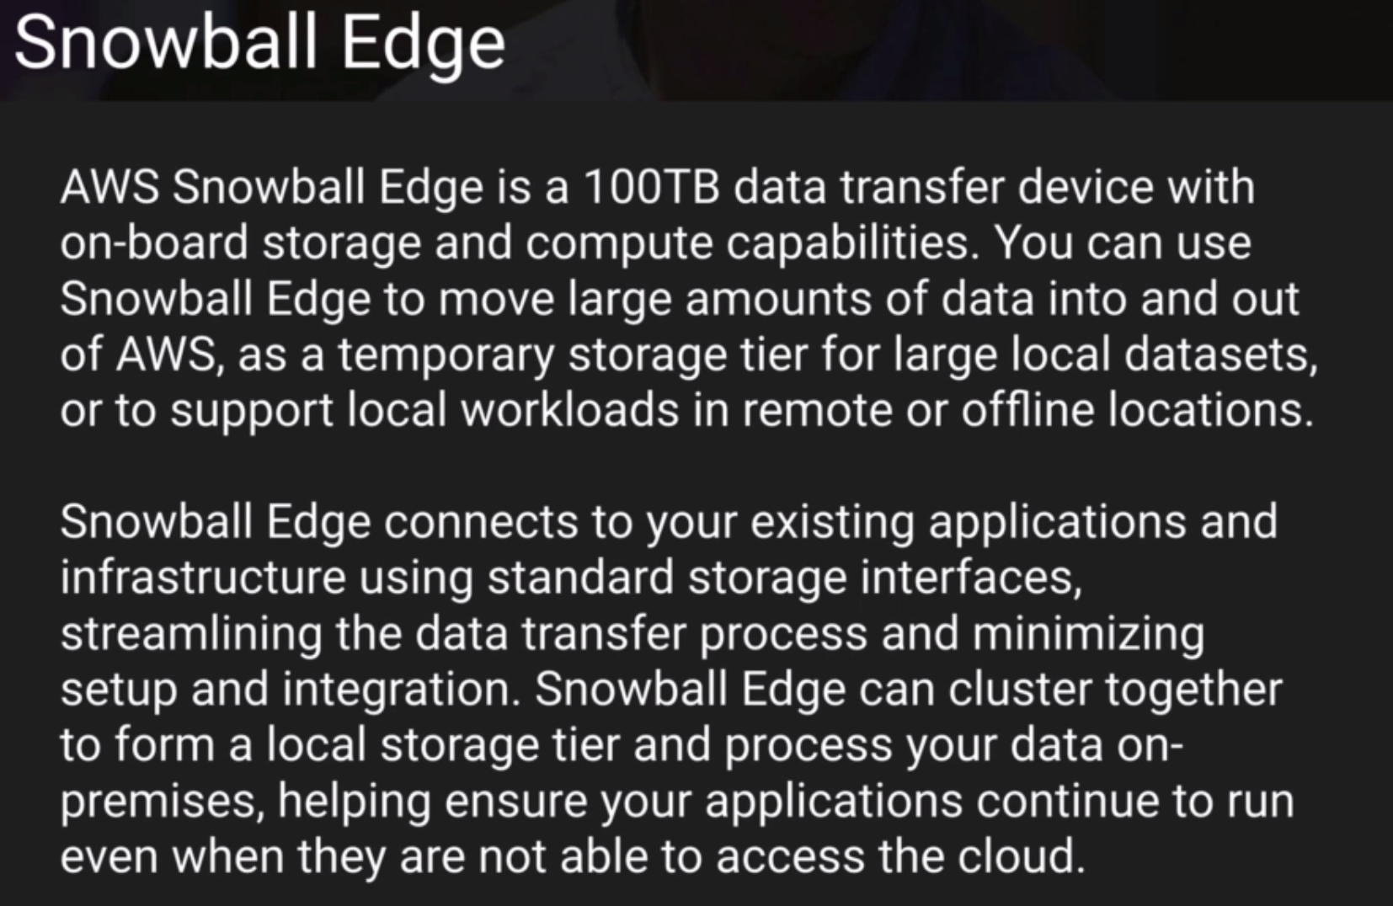

Snowball edge brings compute capacity in addition to storage. It can be plugged to an airplane in flight and a lambda expression can compute and collect data. Then that data can be exported to s3 for analysis.

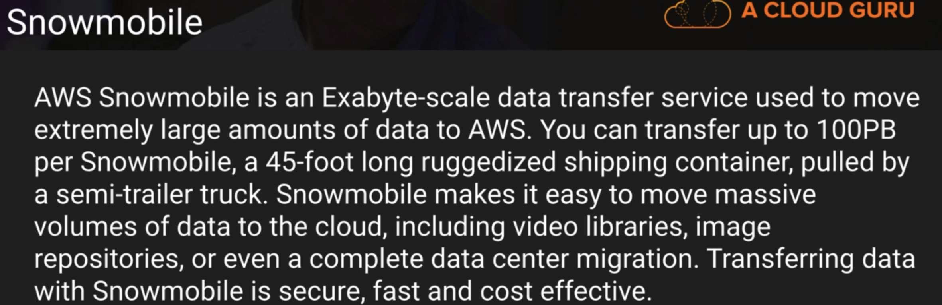

It can move data in 6 months, which would have taken 25 years through internet.

To move data from glacier, it has to be first restored to s3 and then put in a snowball.

To use snowball, we need to download client, connect snowball and run command like below.



To start snowball we will need the ip address displayed in snowball, the manifest file and the access code from aws console snowball job.

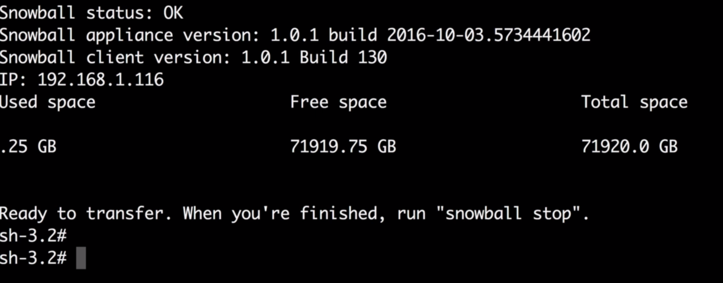

Copy file to be transferred to snowball. The s3 bucket is the one mentioned in the snowball job.

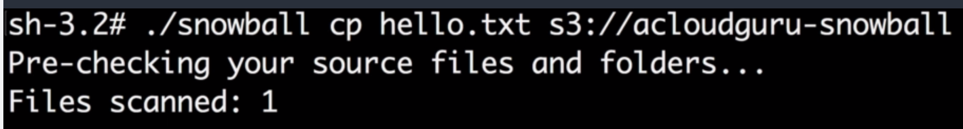

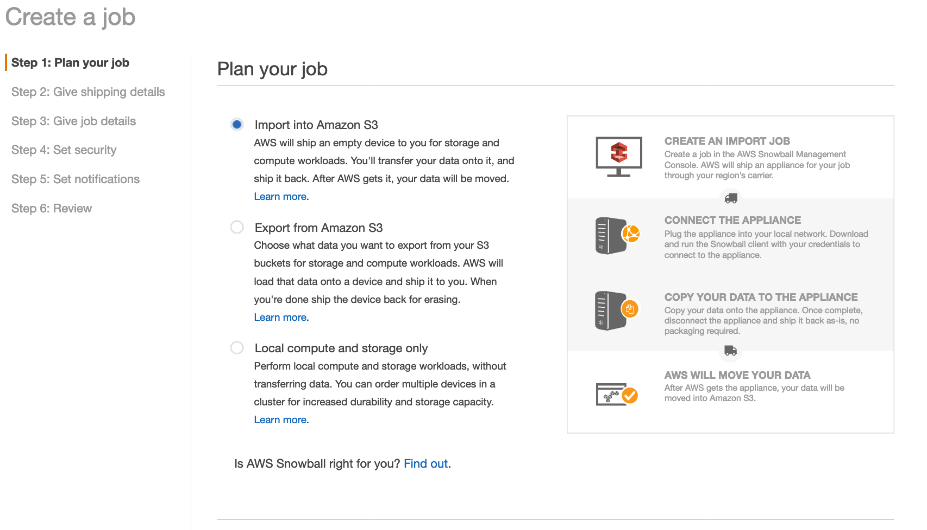

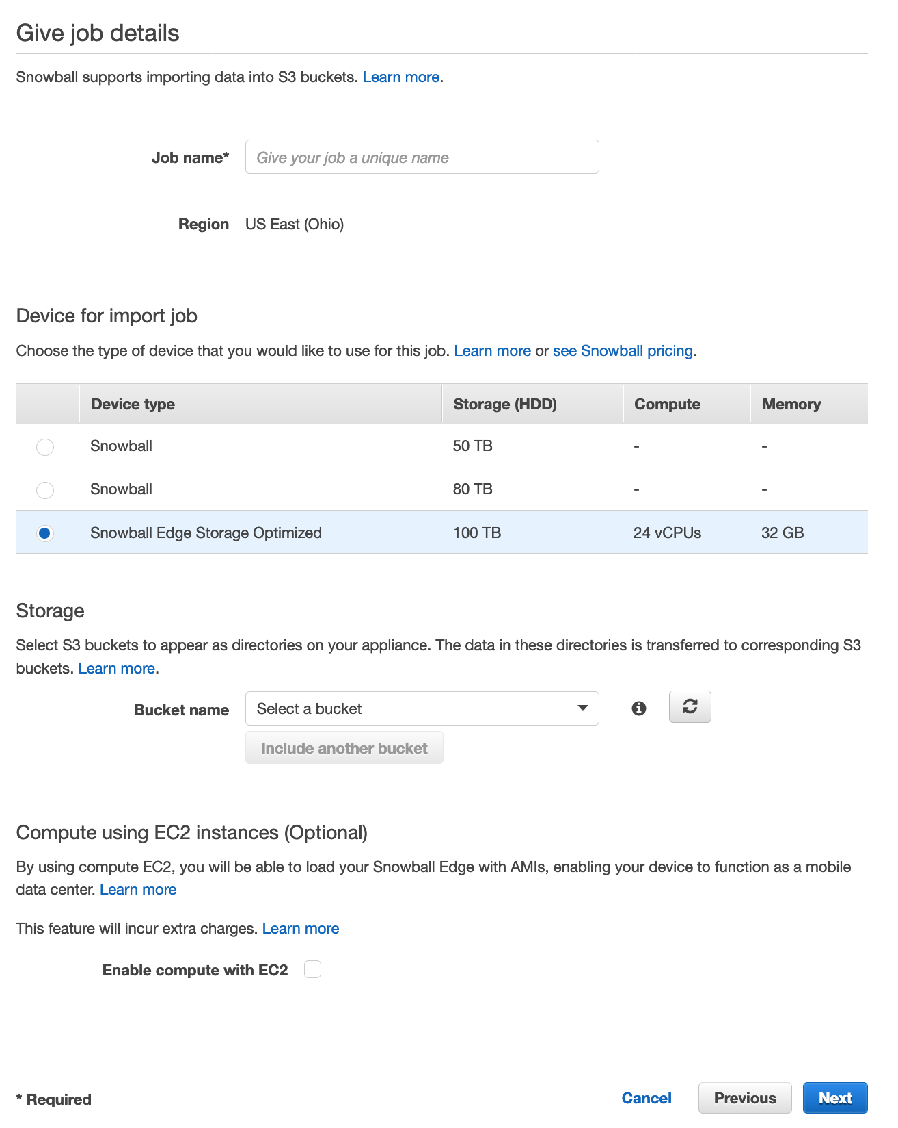

**Transfer Acceleration:**

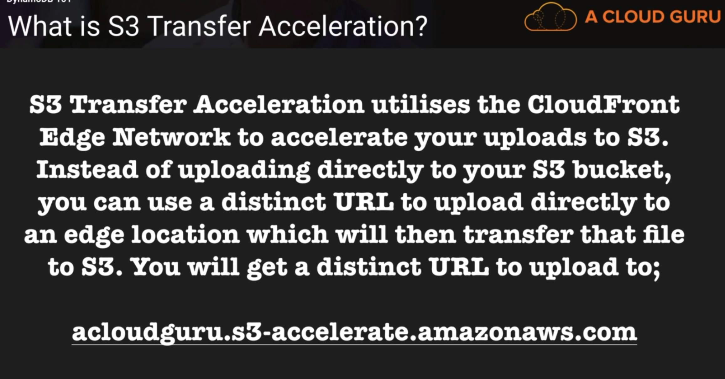

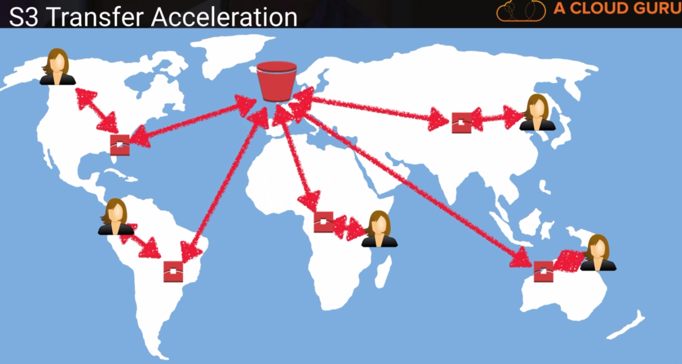

Bucket Properties > Advanced Settings:

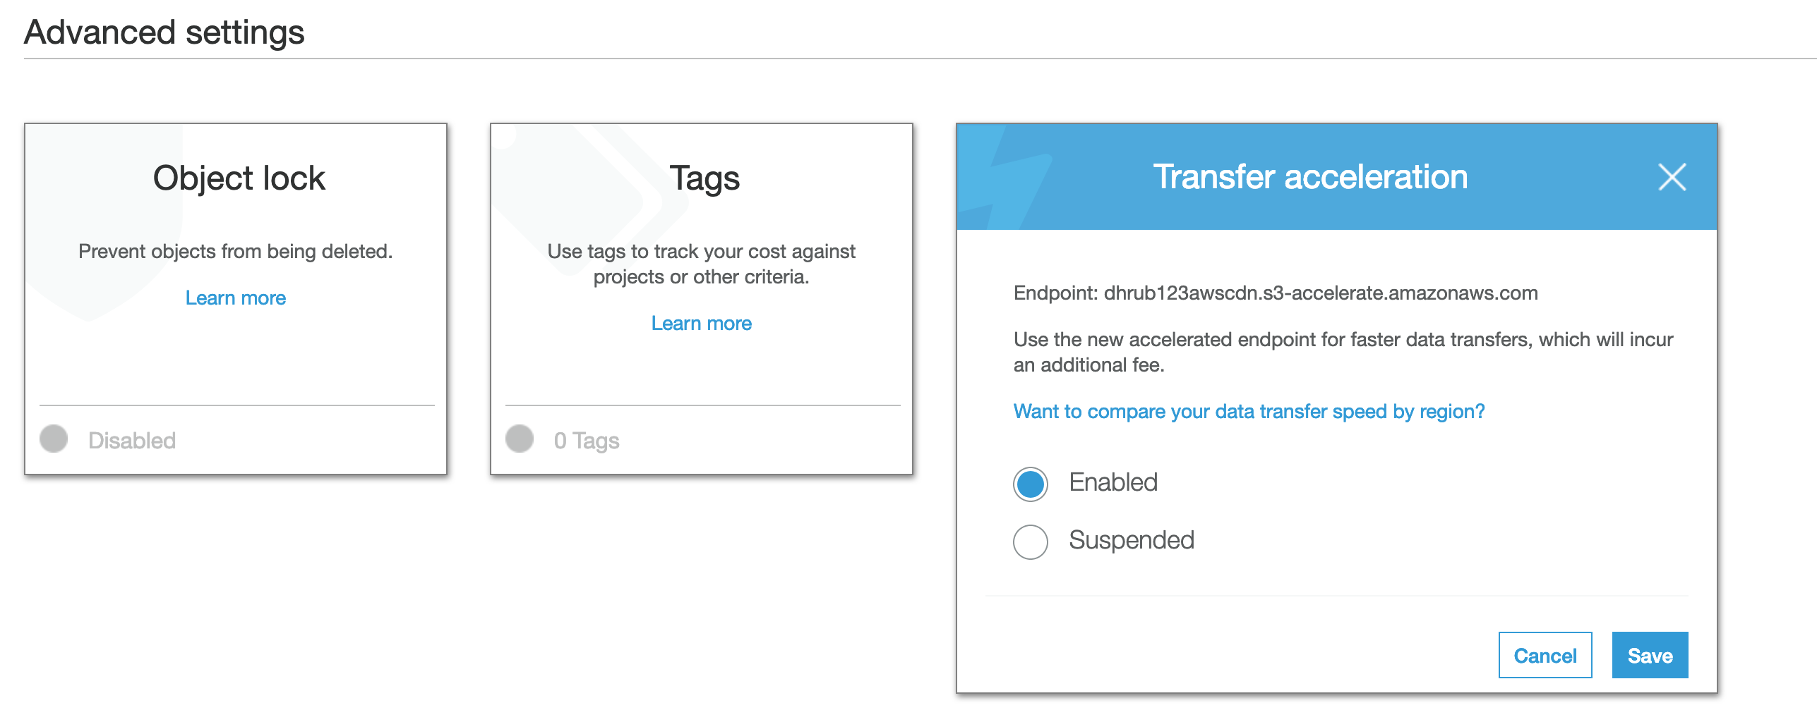

The endpoint is different. It uses a sub domain of s3 called s3-accelerate and uses CloudFront underlying. To compare speeds, click on compare speeds link.

**S3 static website hosting:**

* Bucket policies can be used to make entire buckets public.
* S3 website hosting can only be used for STATIC hosting. Dynamic websites requiring DB connections cannot be hosted in S3.
* It scales automatically to meet demand. A good example can be a movie preview where a large number of requests come to view a static website.

Bucket Properties > Static Website Hosting

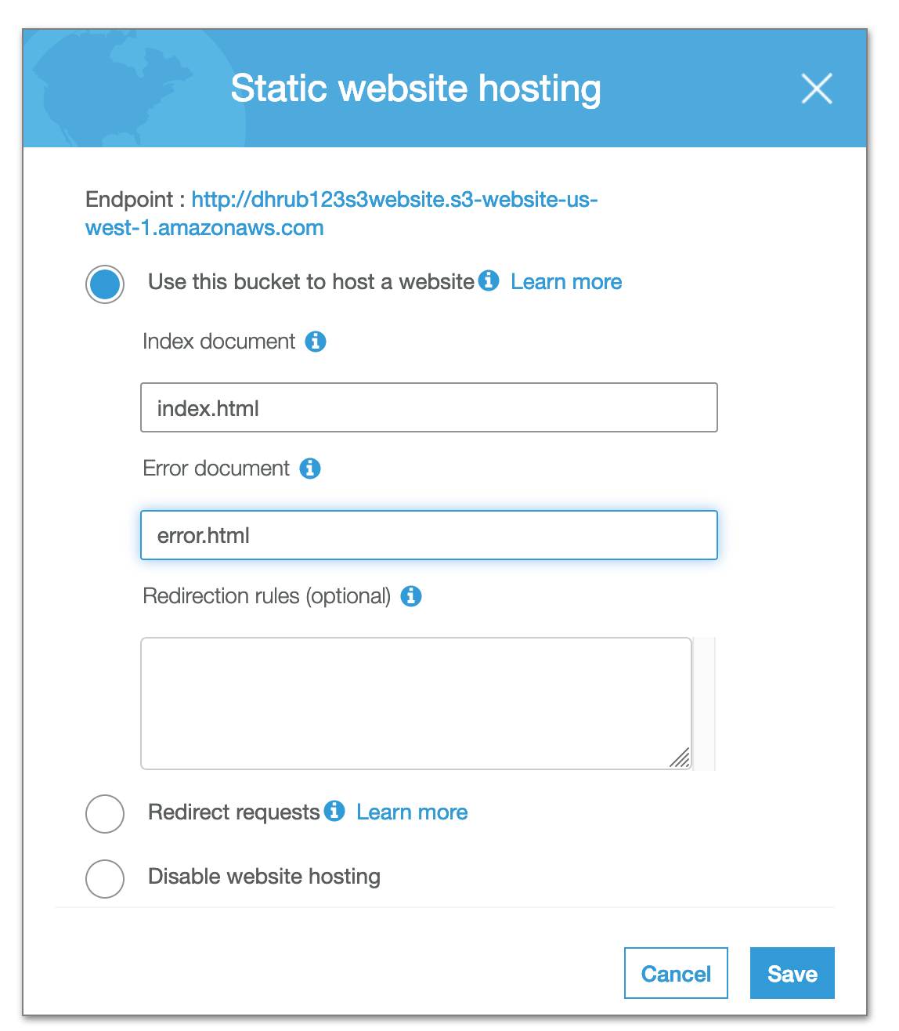

Format of endpoint:

<http://dhrub123s3website.s3-website-us-west-1.amazonaws.com>

<http://bucketname.s3-website-region.amazonaws.com>

We can define the index and error document.

We need to make the bucket and all its contents public.

The bucket policy is changed to make it publicly accessible.

A bucket policy is added to make individual files public.

{

"Version":"2012-10-17",

"Statement":[{

"Sid":"PublicReadGetObject",

"Effect":"Allow",

"Principal": "*",

"Action":["s3:GetObject"],

"Resource":["arn:aws:s3:::dhrub123s3website/*"

]

}

]

}





When we hit <http://dhrub123s3website.s3-website-us-west-1.amazonaws.com/> , we are displayed index.html. When we hit an invalid URL like <http://dhrub123s3website.s3-website-us-west-1.amazonaws.com/e> , we are displayed the error page.